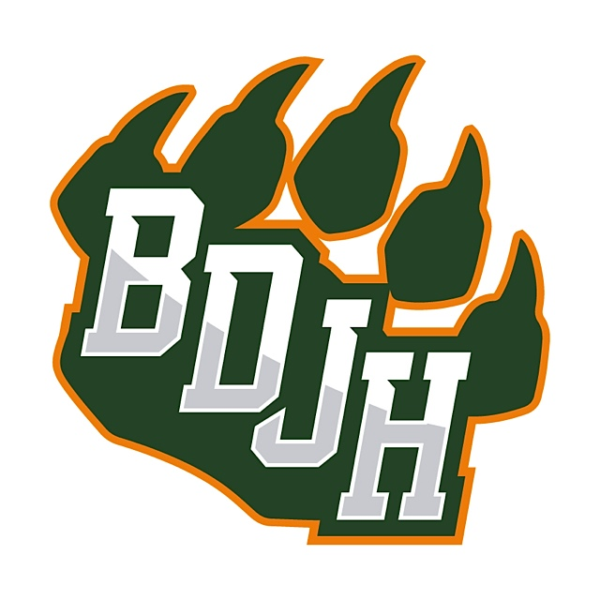
BDJH Yard Sign Order Form
Let the neighbors know you support Beckendorff by proudly displaying one of our GREAT yard signs!
Signs are $55 each and come ready to go in your yard! Please return this order form to school with your check enclosed.
Please make checks payable to BDJH PTA.
Parent Name: _____________________________________________________
Email: __________________ Phone Number: __________________
Student Name: _____________________________________________________
Advisory Teacher: _____________________________________________________
Quantity: ___________
Total Amount Due: ___________
Questions please contact Lauren Williams at mark.lauren.will@sbcglobal.net

